# JS Advanced: Exam 13 November 2016

Problems for exam preparation for the [“JavaScript Advanced” course @ SoftUni](https://softuni.bg/courses/javascript-advanced). Submit your solutions in the SoftUni judge system at <https://judge.softuni.bg/Contests/355/>.

# Problem 1. Add / Remove Towns (Simple DOM Interaction)

You are given the following **HTML code**:

|  |
| --- |
| add-remove-towns.html |
| *<!-- JS Advanced Exam @ SoftUni - 13-Nov-2016 -->* <!DOCTYPE **html**> <**html**> <**head**>  <**meta charset="UTF-8"**>  <**title**>Add / Remove Towns</**title**>  <**style**>**select**, **input** { **width**: 100**px** }</**style**>  <**script src="https://code.jquery.com/jquery-3.1.1.min.js"**></**script**> </**head**>  <**body onload="***attachEvents*()**"**>  <**div**>Towns</**div**> <**select id="towns" size="4"**>  <**option**>Sofia</**option**>  <**option**>Varna</**option**>  <**option**>Pleven</**option**> </**select**>  <**button id="btnDelete"**>Delete</**button**>  <**div**>  <**input type="text" id="newItem"** />  <**button id="btnAdd"**>Add</**button**> </**div**>  <**script**>  **function** *attachEvents*() {  *//* ***TODO:*** …  } </**script**> </**body**> </**html**> |

### Your Task

**Write the** **missing JavaScript code** to make the **[Add]** and **[Delete]** buttons work as expected.

* The **[Add]** button should append the text from the text box as a new item at the end of the list box and clear the input text box after that. If the textbox is empty, it should do nothing.
* The **[Delete]** button should **delete selected item** from the list. If no item is selected, it should do nothing.
  + When an item is selected it has the property selected.

### Examples

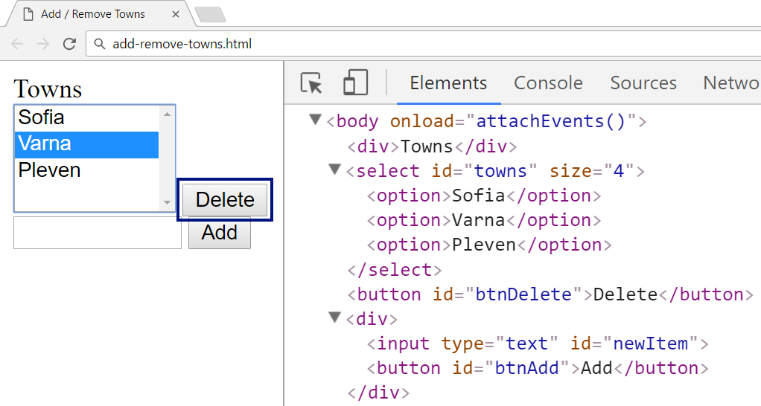

↓

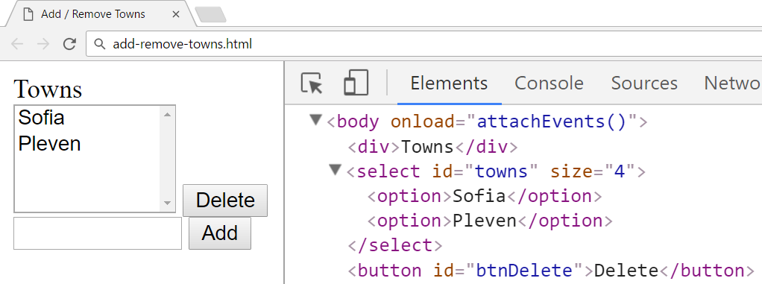

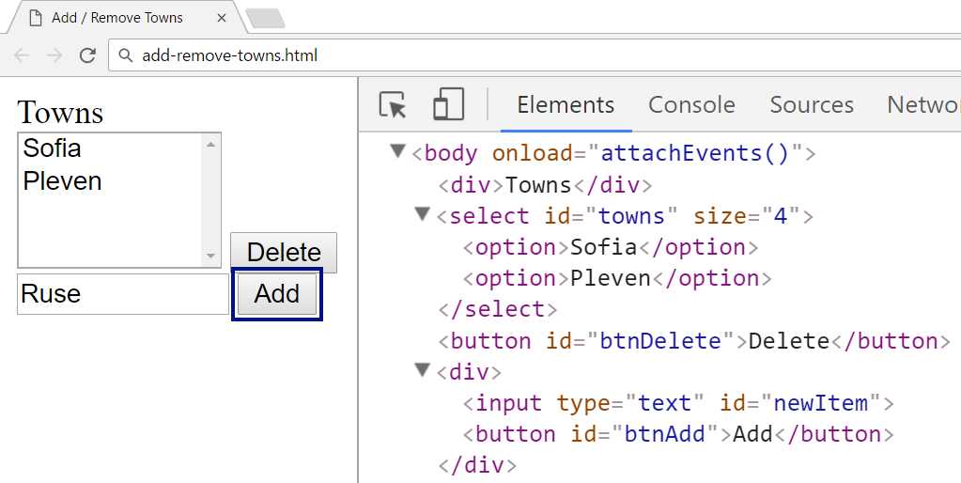

↓

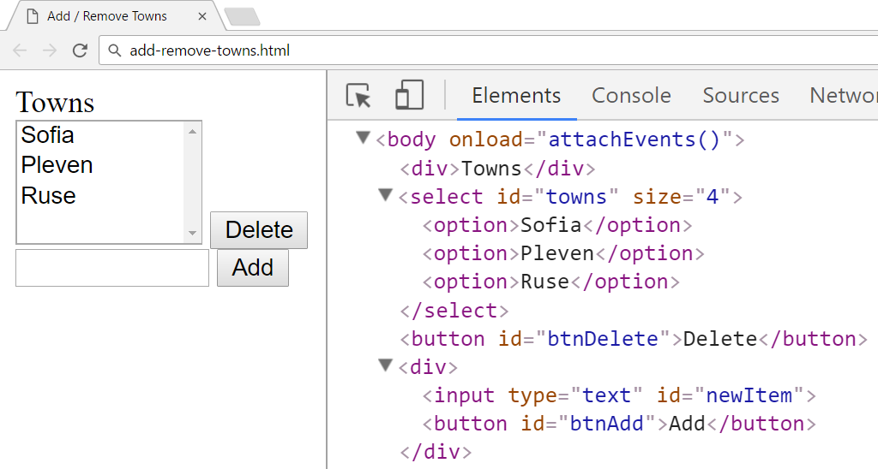

### Submission

Submit your attachEvents function as “**JavaScript code (DOM unit tests)**”.